

Home Kitchen

System Architecture

Team Lead: Ayesha Tahreem Aamir 14L-4473

Members: Hafiza Ramzah Rehman 14L-4342

Mahnoor Fatima 14L-4293

Sana Fatima 14L-4079

Muhammad Bilal Zubairy

Ms. Lehmia Kiran

Software Engineering (Section-A)

Date: 23th October 2017

National University of Computer and Emerging Sciences

Department of Computer Science

Lahore, Pakistan

Table of Contents

1. Architecture Diagram 3

2. Architecture Context Diagram 3

3. Archetypes 4

4. Component Level Diagram 5

4.1 External View 5

4.2 Internal View 6

4.3 Class-level View 6

5. Class Diagram 7

6. Sequence Diagram 8

6.1 Sign Up 8

6.2 Log In 9

6.3 Log Out 10

6.4 Forgot Password 10

6.5 Order Food 11

6.6 Post Food 12

6.7 Review Seller on the basis of Order 13

6.8 Rate Seller on the basis of Order 13

6.9 Edit Profile 14

6.10 View History of Ordered Items 15

System Architecture

This document covers all the major high and low-level designs of HomeKitchen. It contains Architecture Diagram, Architecture Context Diagram, Archetypes, Component Level Diagram, Class Diagram and Sequence Diagram.

# Architecture Diagram

Architecture Diagram of HomeKitchen is as:

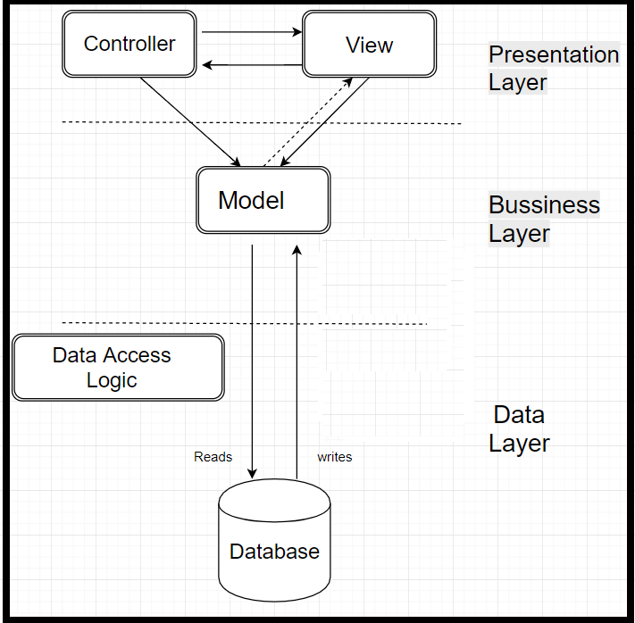

# Architecture Context Diagram

Architecture Context Diagram of HomeKitchen is as:

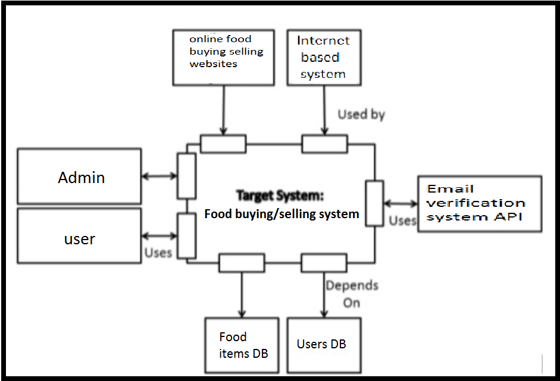

# Archetypes

Archetypes of HomeKitchen is as:

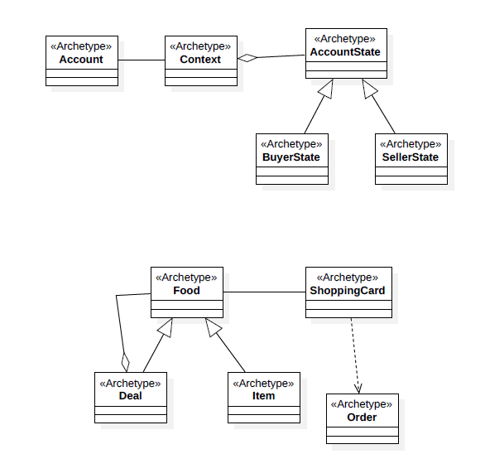

# Component Level Diagram

Component Level Diagram of HomeKitchen at each level i.e., external, internal or class is as:

## External View

Following is the external view of the system.

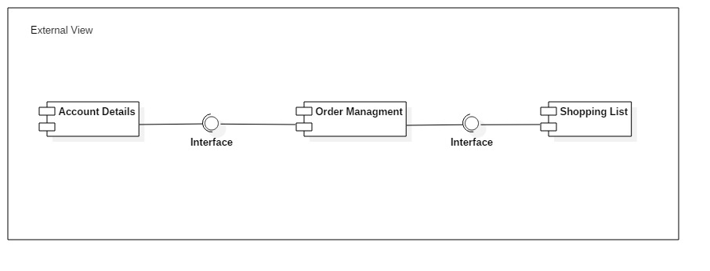

## Internal View

Following is the internal view of the system.

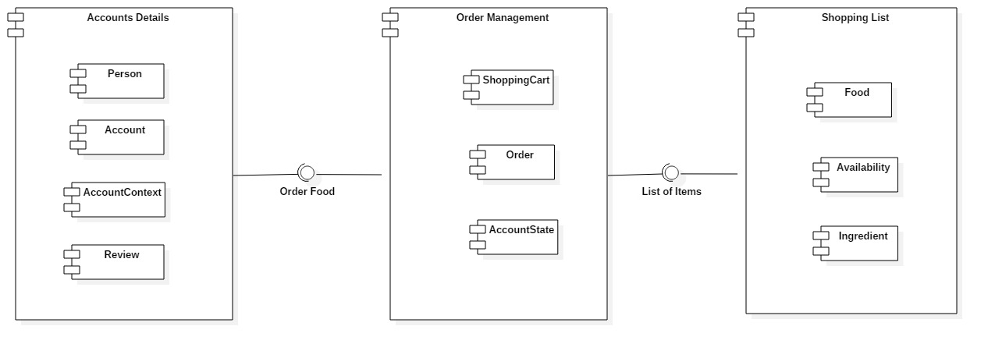

## Class-level View

Following is the class level view of the system.

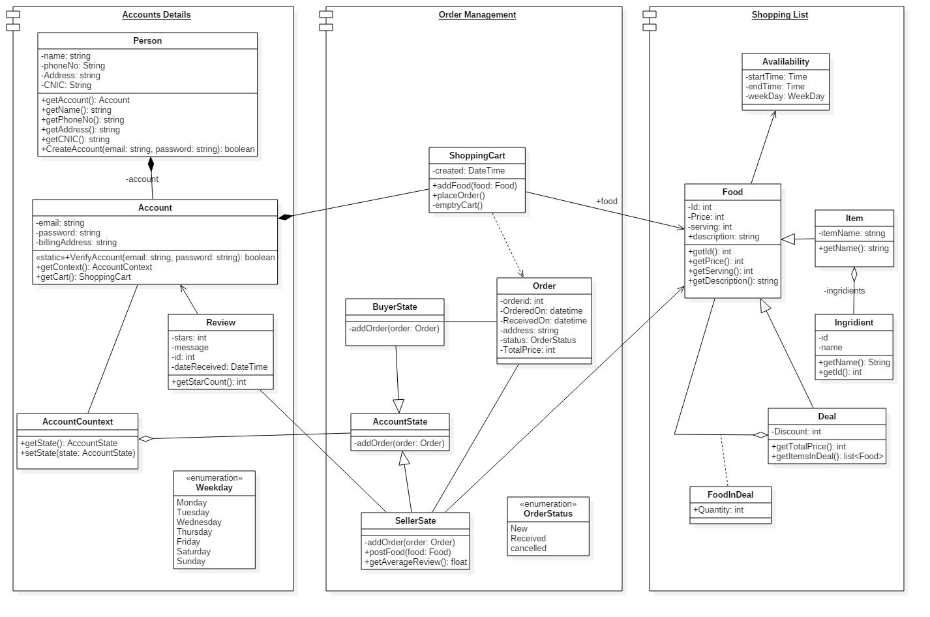

# Class Diagram

Class diagram is as follows:

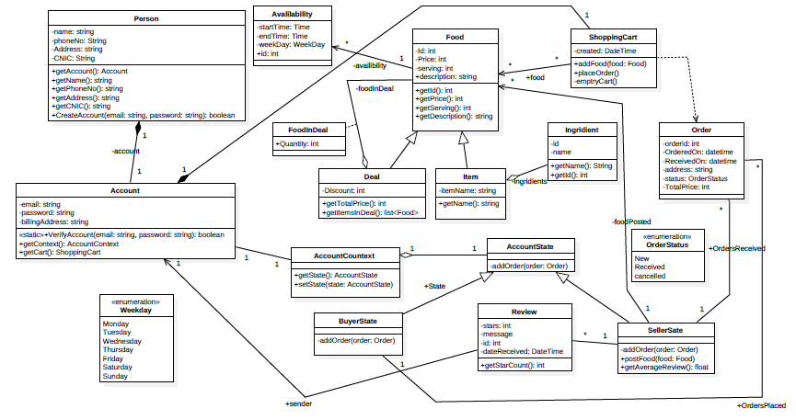

# Sequence Diagram

Following are the sequence diagrams:

## Sign Up

Following is the sequence diagram for signup.

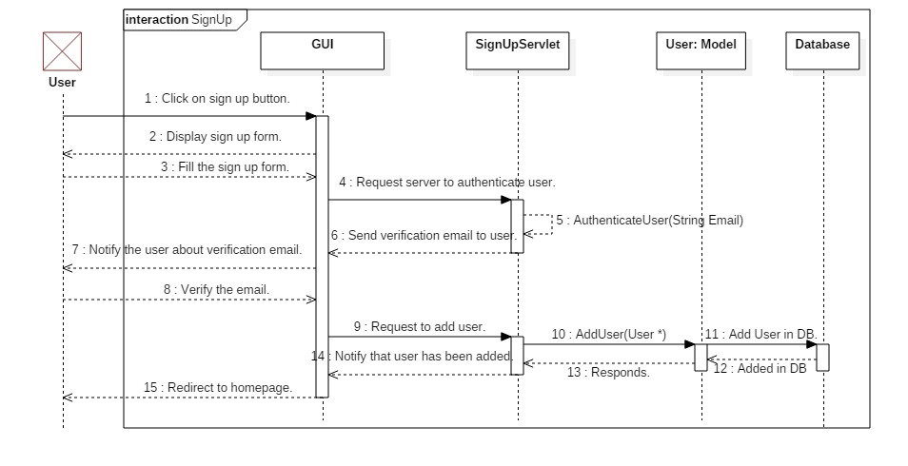

## Log In

Following is the sequence diagram for logging into the system.

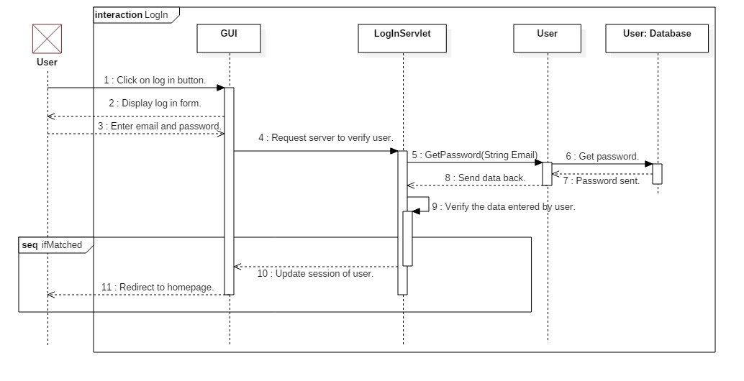

## Log Out

Following is the sequence diagram to log out from the system.

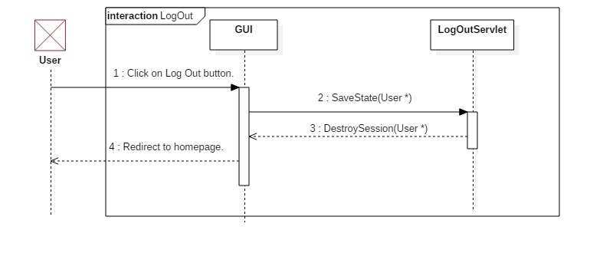

## Forgot Password

Following is the sequence diagram to forgot password.

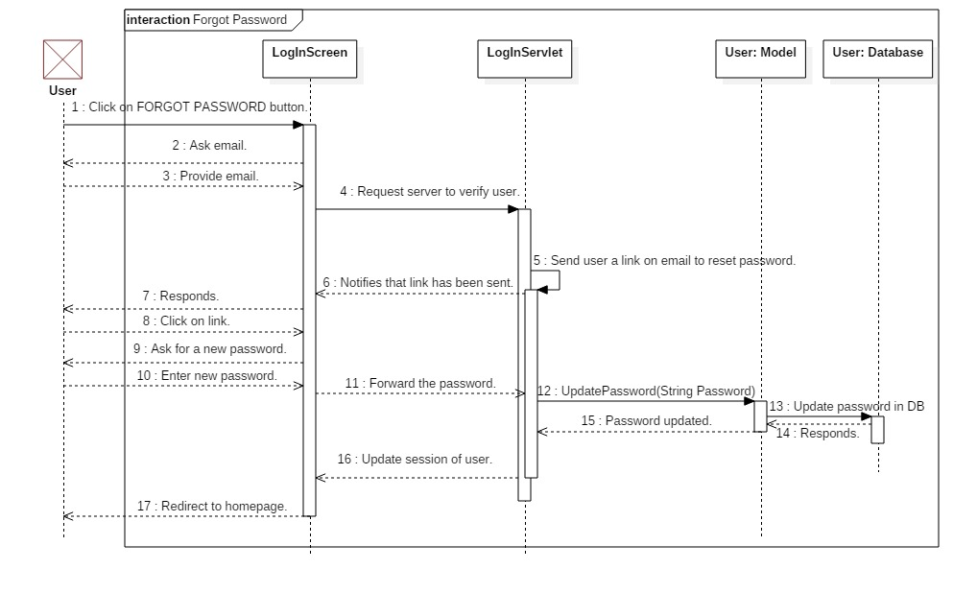

## Order Food

Following is the sequence diagram to order food.

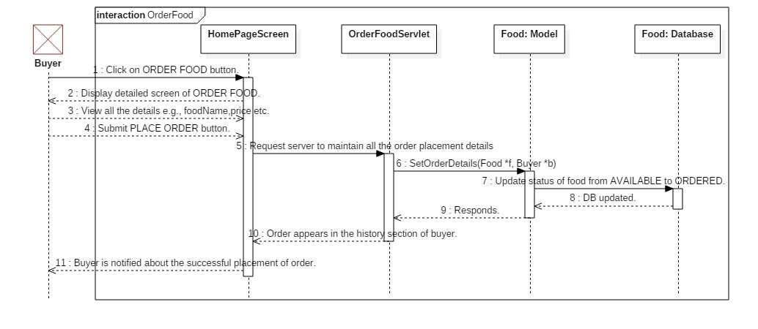

## Post Food

Following is the sequence diagram to post food.

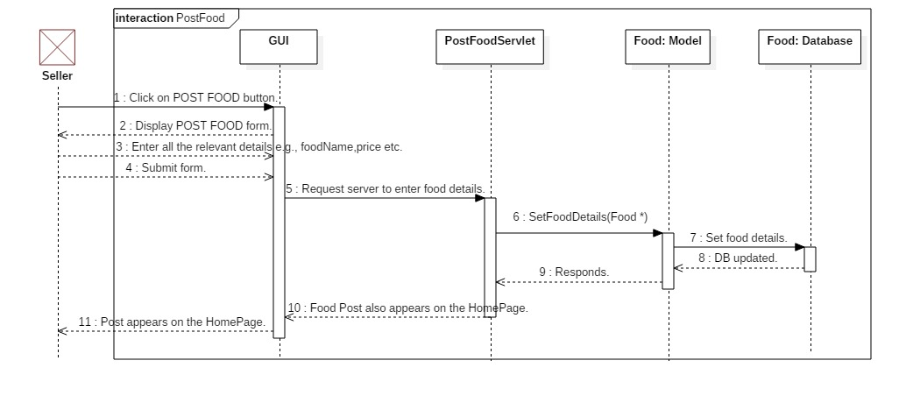

## Review Seller on the basis of Order

Following is the sequence diagram to review the seller on the basis of food provided by him/her.

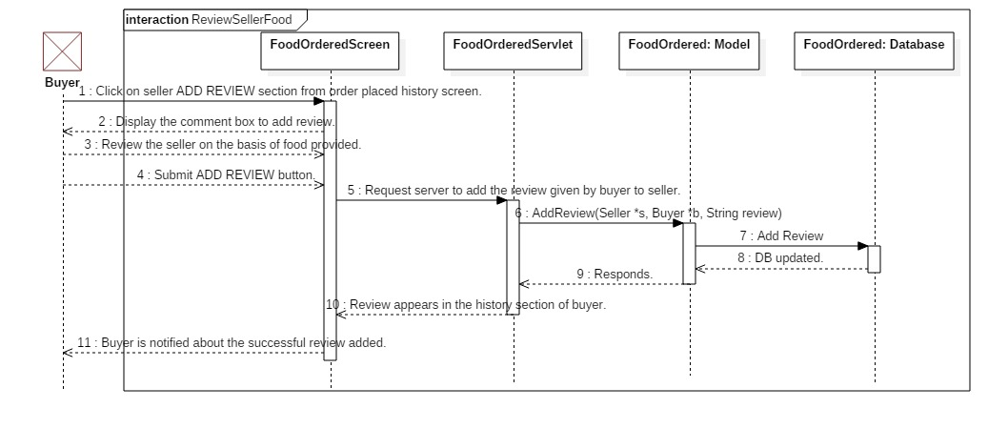

## Rate Seller on the basis of Order

Following is the sequence diagram to rate the seller on the basis of food provided by him/her.

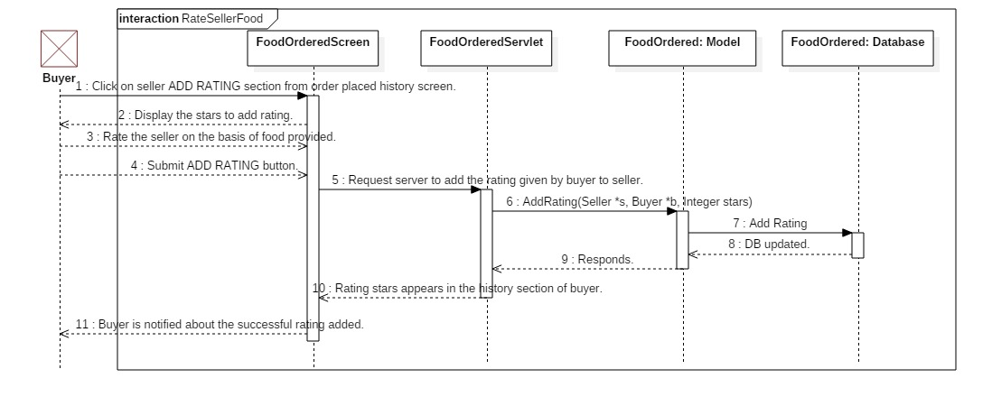

## Edit Profile

Following is the sequence diagram for edit profile.

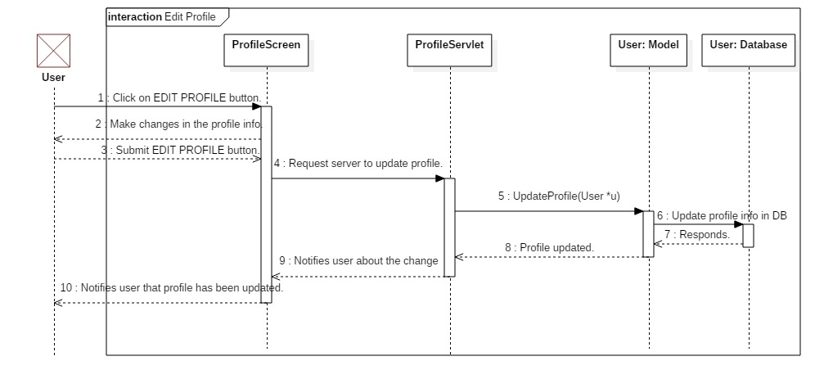

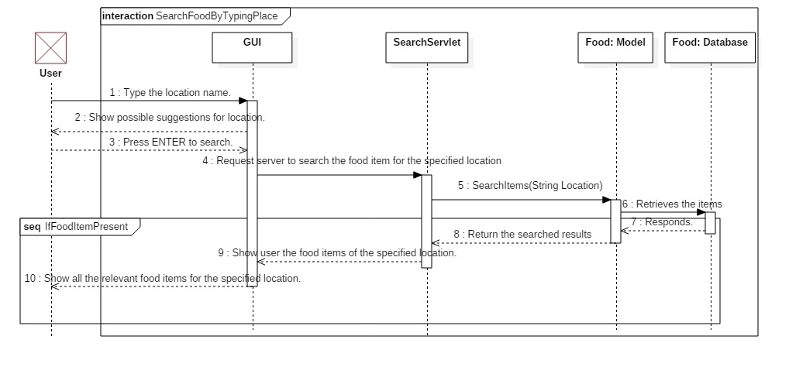

## View History of Ordered Items

Following is the sequence diagram to view history of the ordered items.

